Q1. What is padding and margin and when do you use them?
Ans1. Margin: It is the space around an element. Margins are used to move an element up or down on a page as well as left or right. Margin is completely transparent, and it does not have any background color. It clears the area around the element. Each side of the element has a margin size you can change individually. In creating the gap, the margin pushes adjacent elements away.

CSS code:
.center {
margin: auto;
background: lime;
width: 66%;
}

.outside {
margin: 3rem 0 0 -3rem;
background: cyan;
width: 66%;
}

Padding: It is the space between the element and the related content inside it. It determines how elements look and sit within a container. It also shows the container background around the element in it. Padding can be affected by background colors as it clears the area around the content. To create the gap, it either grows the element size or shrinks the content inside. By default, the size of the element increases.

CSS code:
h4 {
background-color: lime;
padding: 20px 50px;
}

h3 {
background-color: cyan;
padding: 110px 50px 50px 110px;
}

Margin | Padding
The outer space of an element i.e. margin is the space outside the border. | The inner space of an element i.e.padding is space inside the element’s border.
It can be negative or any float number. | It does not allow negative values.
We can set the margin to auto. | We cannot set the padding to auto.
Styling of an element such as background color does not affect the margin. | Padding is affected by the styling of an element, such as background color.
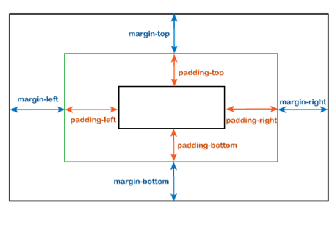

Q2. What is display property and explain display inline, block, and inline-block?
Ans2. The display: inline-block Value
Compared to display: inline, the major difference is that display: inline-block allows to set a width and height on the element.
Also, with display: inline-block, the top and bottom margins/paddings are respected, but with display: inline they are not.
Compared to display: block, the major difference is that display: inline-block does not add a line-break after the element, so the element can sit next to other elements.
The following example shows the different behavior of display: inline, display: inline-block and display: block:
Example
span.a {
display: inline; /* the default for span */
width: 100px;
height: 100px;
padding: 5px;
border: 1px solid blue;
background-color: yellow;
}
span.b {
display: inline-block;
width: 100px;
height: 100px;
padding: 5px;
border: 1px solid blue;
background-color: yellow;
}
span.c {
display: block;
width: 100px;
height: 100px;
padding: 5px;
border: 1px solid blue;
background-color: yellow;
}

block
The element generates a block element box, generating line breaks both before and after the element when in the normal flow.

inline
The element generates one or more inline element boxes that do not generate line breaks before or after themselves. In normal flow, the next element will be on the same line if there is space.

inline-block
The element generates a block element box that will be flowed with surrounding content as if it were a single inline box (behaving much like a replaced element would).
It is equivalent to inline flow-root.

Q3. Explain min-height, min-width, max-height, and max-width in CSS.
Ans3.
Property | Description
height | Sets the height of an element
max-height | Sets the maximum height of an element
max-width | Sets the maximum width of an element
min-height | Sets the minimum height of an element
min-width | Sets the minimum width of an element
width | Sets the width of an element
The height and width properties may have the following values:
- auto - This is default. The browser calculates the height and width
- length - Defines the height/width in px, cm, etc.
- % - Defines the height/width in percent of the containing block
- initial - Sets the height/width to its default value
- inherit - The height/width will be inherited from its parent value

